Modifying Data – Exercises

Student Table creation

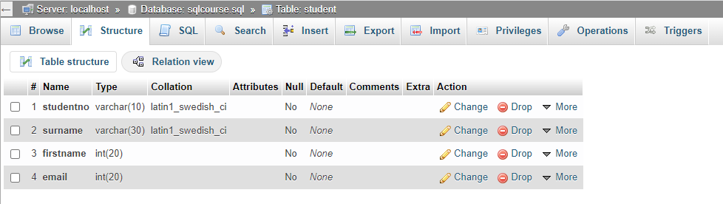

Exercise 01:

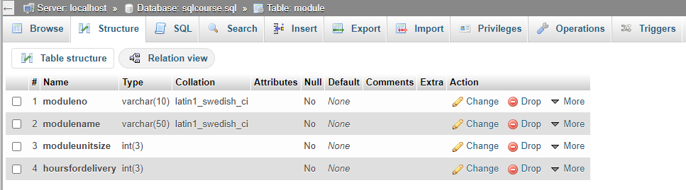

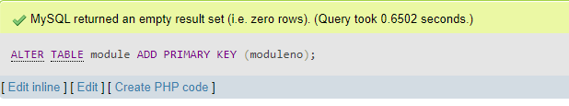

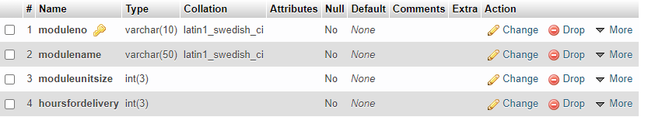

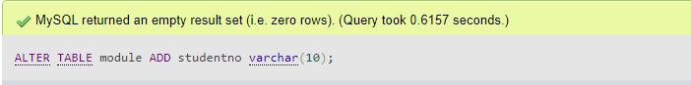

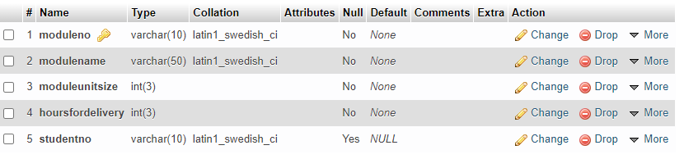

Altered tables:

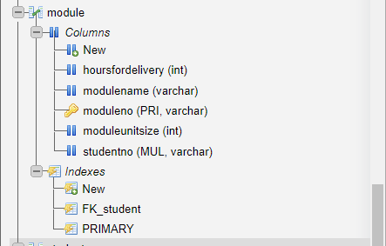

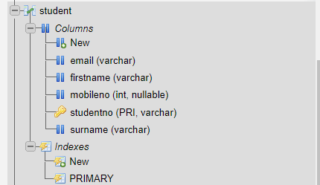

Activity 1: Modify Data:

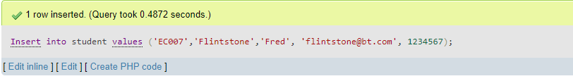

Exercise 2:

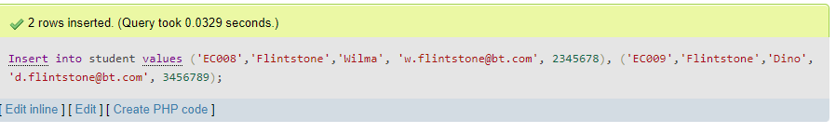

Exercise 3:

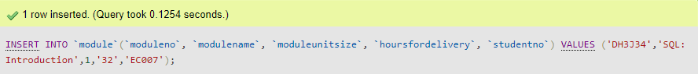

Exercise 4

Before Update

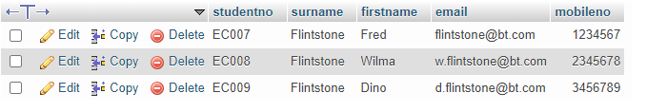

After update Fred to Barney

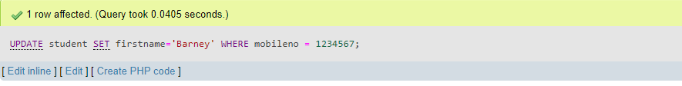

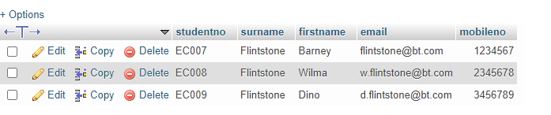

Update back to Fred

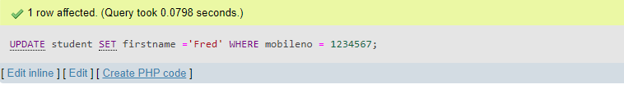

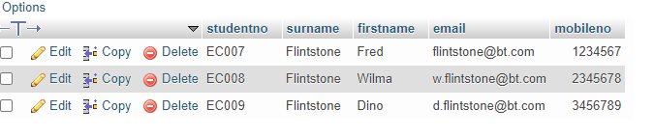

Exercise 5

SELECT

surname,

firstname,

student.studentno,

modulename

FROM

student, module

WHERE

student.studentno = module.studentno;

